Locus of Points on a Fixed Line

Definition
# Source: AI Source: Provided by: [Data Path: Persons Table -> ID Column: 1, Name_En Column: Motasem Essam] -> From: [ChatGPT] on [7/25/2026]
The locus of points on a fixed line is the set of all points that lie on a given fixed line.
If $l$is a fixed line, then every point $P$satisfying:
$$\boxed{P∈l}$$
belongs to the locus.
Therefore, the locus is simply the entire fixed line.
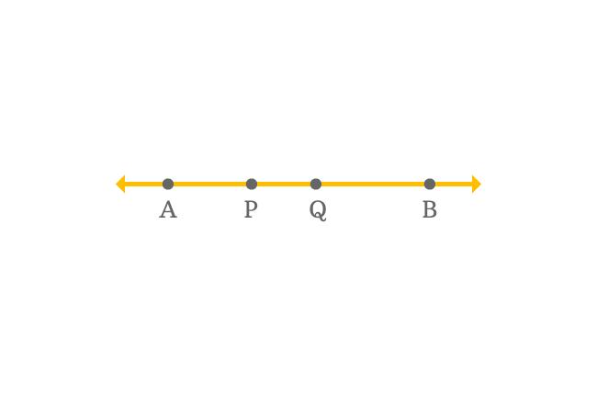
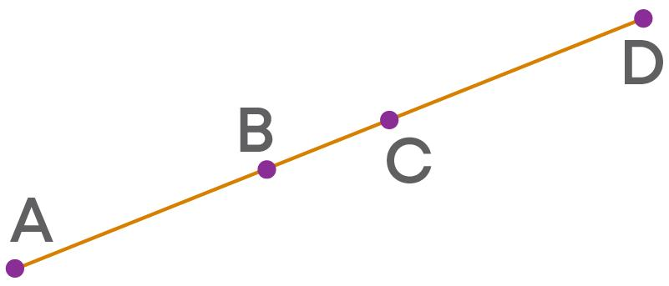
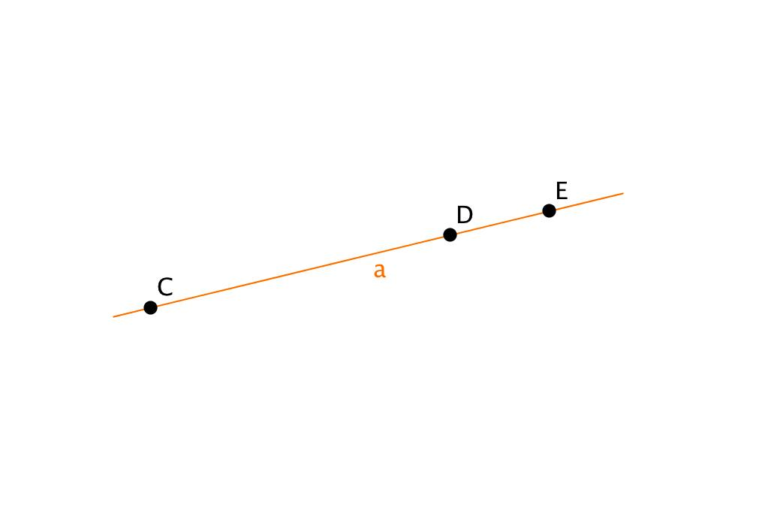

Simple Definition
# Source: AI Source: Provided by: [Data Path: Persons Table -> ID Column: 1, Name_En Column: Motasem Essam] -> From: [ChatGPT] on [7/25/2026]
The locus of points on a fixed line is the line itself.
For example, if the fixed line is:
$$y=3,$$
then every point of the form:
$$\left(x , 3\right)$$
belongs to the locus.
Thus:
$$\boxed{\text{Locus}=y=3}$$

Fundamental Concept
# Source: AI Source: Provided by: [Data Path: Persons Table -> ID Column: 1, Name_En Column: Motasem Essam] -> From: [ChatGPT] on [7/25/2026]
A locus is determined by a condition that points must satisfy.
For a fixed-line locus, the condition is simply:
$$\boxed{P\text{ lies on the fixed line }l}$$
Unlike a distance locus, there is no additional measurement condition such as:
$$PA=r$$
or:
$$d\left(P , l\right)=r.$$
The geometric object itself is the locus.
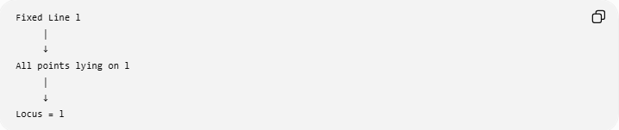
Fixed Line l
│
↓
All points lying on l
│
↓
Locus = l

Main Structure
# Source: AI Source: Provided by: [Data Path: Persons Table -> ID Column: 1, Name_En Column: Motasem Essam] -> From: [ChatGPT] on [7/25/2026]
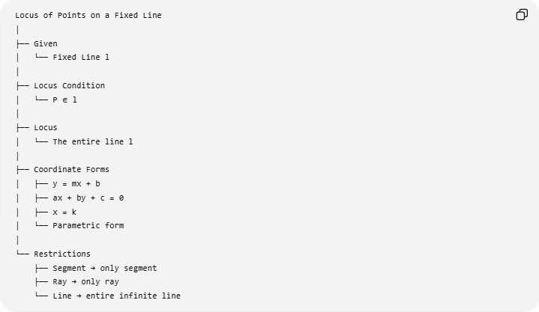
Locus of Points on a Fixed Line
│
├── Given
│ └── Fixed Line l
│
├── Locus Condition
│ └── P ∈ l
│
├── Locus
│ └── The entire line l
│
├── Coordinate Forms
│ ├── y = mx + b
│ ├── ax + by + c = 0
│ ├── x = k
│ └── Parametric form
│
└── Restrictions
├── Segment → only segment
├── Ray → only ray
└── Line → entire infinite line

Example 1 — Horizontal Line
# Source: AI Source: Provided by: [Data Path: Persons Table -> ID Column: 1, Name_En Column: Motasem Essam] -> From: [ChatGPT] on [7/25/2026]
Consider the fixed line:
$$y=4.$$
Every point of the form:
$$P=\left(x , 4\right)$$
lies on this line.
Examples include:
$$\left(0 , 4\right), \left(2 , 4\right), \left(- , 54\right), \left(100 , 4\right).$$
Therefore, the locus is:
$$\boxed{y=4}$$
There is no restriction on $x$.
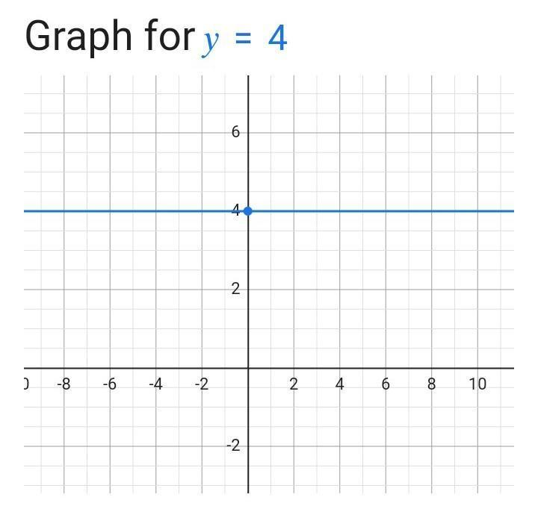
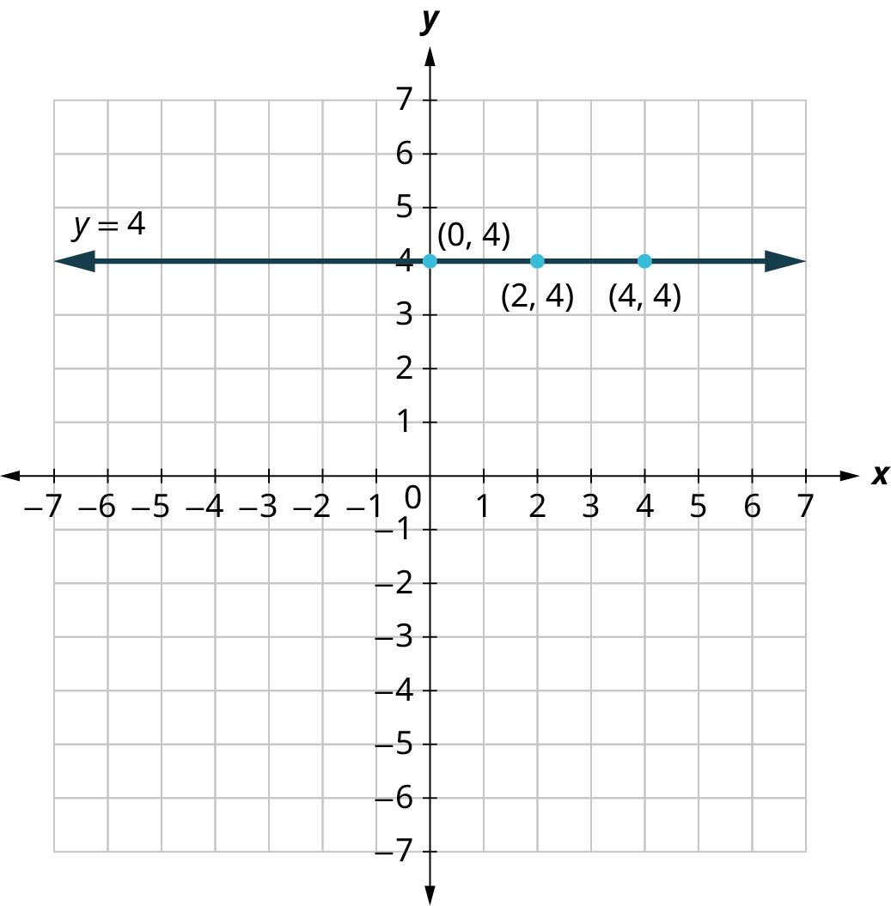
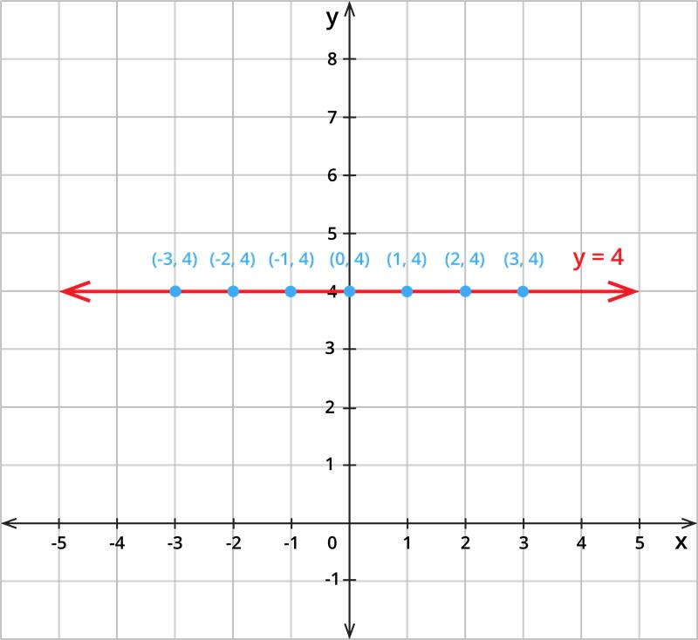
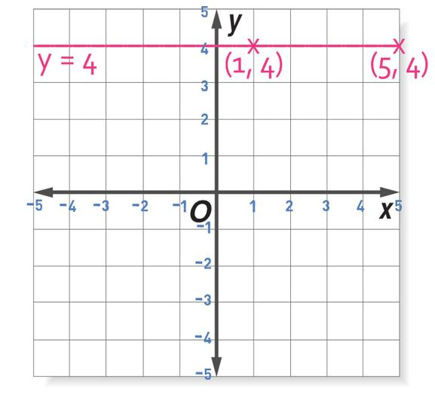
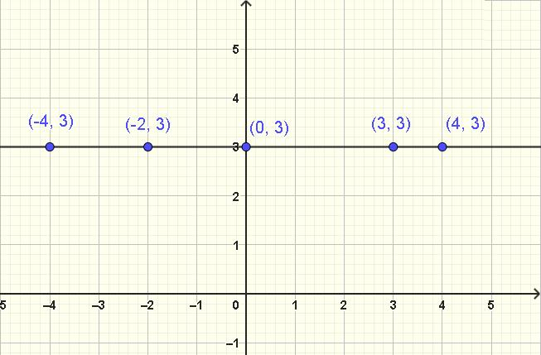

Example 2 — Vertical Line
# Source: AI Source: Provided by: [Data Path: Persons Table -> ID Column: 1, Name_En Column: Motasem Essam] -> From: [ChatGPT] on [7/25/2026]
Consider:
$$x=3.$$
Every point of the form:
$$P=\left(3 , y\right)$$
belongs to the locus.
Examples:
$$\left(3 , 0\right), \left(3 , 2\right), \left(3 , -7\right), \left(3 , 100\right).$$
Therefore:
$$\boxed{x=3}$$
is the locus.

Example 3 — General Line
# Source: AI Source: Provided by: [Data Path: Persons Table -> ID Column: 1, Name_En Column: Motasem Essam] -> From: [ChatGPT] on [7/25/2026]
Suppose the fixed line is:
$$2x+3y-6=0.$$
The locus is simply:
$$\boxed{2x+3y-6=0}.$$
Any point satisfying this equation belongs to the locus.
For example, choose:
$$x=0.$$
Then:
$$2\left(0\right)+3y-6=0$$
so:
$$3y=6$$
and:
$$y=2.$$
Therefore:
$$\left(0 , 2\right)$$
is on the locus.
Another point:
$$x=3$$
gives:
$$2\left(3\right)+3y-6=0 \\ 3y=0 \\ y=0.$$
Thus:
$$\left(3 , 0\right)$$
is also on the locus.

Coordinate Representation
# Source: AI Source: Provided by: [Data Path: Persons Table -> ID Column: 1, Name_En Column: Motasem Essam] -> From: [ChatGPT] on [7/25/2026]
A fixed line can be represented in several ways.
Standard form
$$\boxed{ax+by+c=0}$$
Slope-intercept form
$$\boxed{y=mx+b}$$
Vertical-line form
$$\boxed{x=k}$$
Parametric form
$$\boxed{x=x_{0}+at, y=y_{0}+bt}$$
where:
$$t∈R.$$
Each representation describes the same type of locus: a line.

Parametric Interpretation
# Source: AI Source: Provided by: [Data Path: Persons Table -> ID Column: 1, Name_En Column: Motasem Essam] -> From: [ChatGPT] on [7/25/2026]
Suppose a line passes through:
$$P_{0}=\left(x_{0} , y_{0}\right)$$
with direction vector:
$$\vec{v}=\left(a , b\right).$$
Then every point on the line can be written:
$$\boxed{P\left(t\right)=\left(x_{0} , +at y_{0}+bt\right)}$$
where:
$$t∈R.$$
As $t$varies over all real numbers, the point moves through the entire line.
For example:
$$P\left(t\right)=\left(2 , +t3+2t\right).$$
When:
$$t=0,$$
we obtain:
$$\left(2 , 3\right).$$
When:
$$t=1,$$
we obtain:
$$\left(3 , 5\right).$$
When:
$$t=-1,$$
we obtain:
$$\left(1 , 1\right).$$
All these points belong to the same line.

Fixed Line vs. Segment vs. Ray
# Source: AI Source: Provided by: [Data Path: Persons Table -> ID Column: 1, Name_En Column: Motasem Essam] -> From: [ChatGPT] on [7/25/2026]
This distinction is important.
Fixed line
A line extends infinitely in both directions:
$$\boxed{P∈\overset{↔}{AB}}$$
The locus contains the entire line.
Fixed segment
If the condition is:
$$P∈\overset{‾}{AB},$$
the locus is only the finite segment.
Fixed ray
If:
$$P∈\vec{AB},$$
the locus is the ray starting at $A$and extending through $B$.
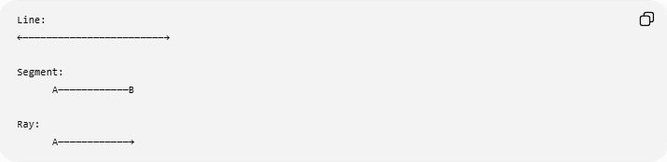
Line:
←────────────────────────→

Segment:
A────────────B

Ray:
A────────────→
Thus:
$$\boxed{\text{Line}≠\text{Segment}≠\text{Ray}}$$

Locus on a Fixed Line with an Additional Condition
# Source: AI Source: Provided by: [Data Path: Persons Table -> ID Column: 1, Name_En Column: Motasem Essam] -> From: [ChatGPT] on [7/25/2026]
Sometimes the fixed line is only part of the locus condition.
For example:
Find the points on line $l$that are 5 units from point $A$.
Then the conditions are:
$$P∈l$$
and:
$$PA=5.$$
The first condition gives a line, while the second gives a circle.
Their intersection usually consists of:
$$\boxed{0, 1,\text{ or }2\text{ points}}$$
depending on how the line intersects the circle.
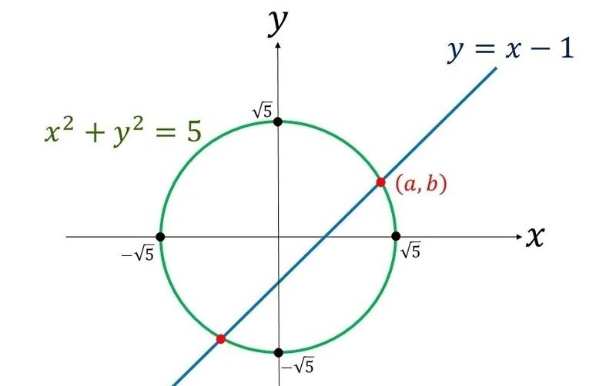
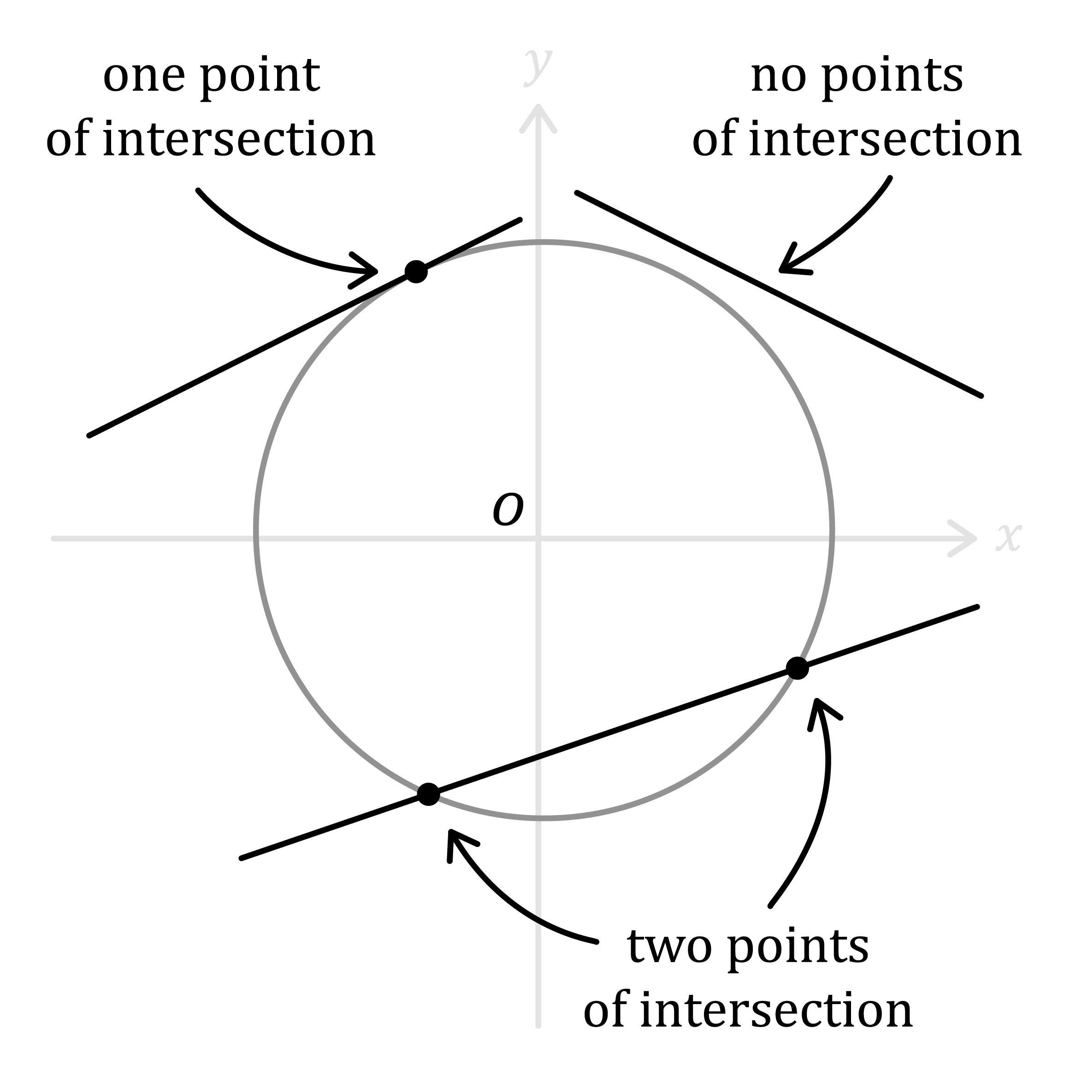
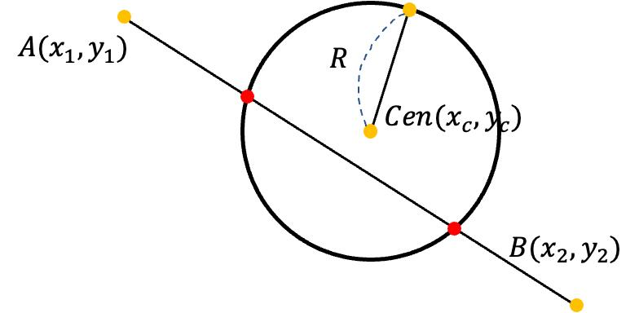
For example, if:
$$l:y=0$$
and:
$$PA=5,$$
then the possible points are the intersections of the $x$-axis with the circle centered at $A$with radius $5$.

Locus of a Moving Point on a Fixed Line
# Source: AI Source: Provided by: [Data Path: Persons Table -> ID Column: 1, Name_En Column: Motasem Essam] -> From: [ChatGPT] on [7/25/2026]
A common interpretation of this locus is a moving point.
Suppose $P$is constrained to move along a fixed line $l$.
Then:
$$\boxed{P∈l}$$
at every moment.
Therefore, the path traced by $P$is:
$$\boxed{l}$$
For example, a point moving along a straight railway track has a straight-line locus if the track is idealized as a line.

Relation to Geometric Constructions
# Source: AI Source: Provided by: [Data Path: Persons Table -> ID Column: 1, Name_En Column: Motasem Essam] -> From: [ChatGPT] on [7/25/2026]
A fixed line can serve as a locus when constructing geometric objects.
Example: Vertex with fixed base and fixed altitude
Suppose $AB$is fixed and a point $C$must satisfy:
$$d\left(C , AB\right)=h.$$
Then $C$lies on one of the two lines parallel to $AB$at distance $h$.
Here, the fixed line itself becomes the reference object, while the actual locus is a pair of parallel lines.
This illustrates an important distinction:
$$\boxed{P∈l}$$
means the fixed line itself is the locus, whereas:
$$\boxed{d\left(P , l\right)=h}$$
produces parallel lines around the fixed line.

Relation to Other Loci
# Source: AI Source: Provided by: [Data Path: Persons Table -> ID Column: 1, Name_En Column: Motasem Essam] -> From: [ChatGPT] on [7/25/2026]
A fixed line is one of the simplest possible loci.
Compare:
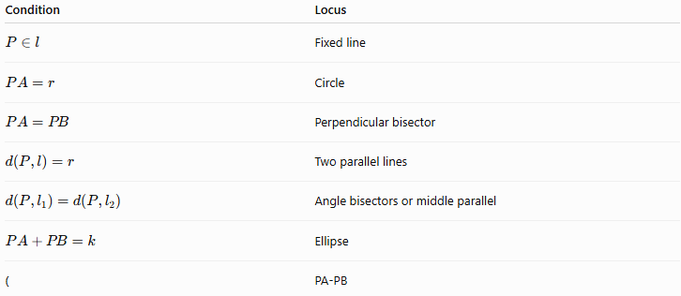
Condition | Locus
$$P∈l$$ | Fixed line
$$PA=r$$ | Circle
$$PA=PB$$ | Perpendicular bisector
$$d\left(P , l\right)=r$$ | Two parallel lines
$$d\left(P , l_{1}\right)=d\left(P , l_{2}\right)$$ | Angle bisectors or middle parallel
$$PA+PB=k$$ | Ellipse
( | PA-PB
The condition directly determines the geometric shape.

Special Coordinate Cases
# Source: AI Source: Provided by: [Data Path: Persons Table -> ID Column: 1, Name_En Column: Motasem Essam] -> From: [ChatGPT] on [7/25/2026]
Horizontal line
$$\boxed{y=k}$$
Vertical line
$$\boxed{x=k}$$
Line through the origin
$$\boxed{y=mx}$$
General line
$$\boxed{ax+by+c=0}$$
All represent straight-line loci.

Important Properties
# Source: AI Source: Provided by: [Data Path: Persons Table -> ID Column: 1, Name_En Column: Motasem Essam] -> From: [ChatGPT] on [7/25/2026]
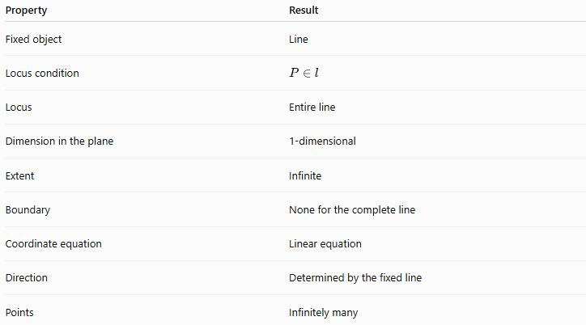
Property | Result
Fixed object | Line
Locus condition | $$P∈l$$
Locus | Entire line
Dimension in the plane | 1-dimensional
Extent | Infinite
Boundary | None for the complete line
Coordinate equation | Linear equation
Direction | Determined by the fixed line
Points | Infinitely many

Important Distinction: Line as a Locus vs. Line as a Reference
# Source: AI Source: Provided by: [Data Path: Persons Table -> ID Column: 1, Name_En Column: Motasem Essam] -> From: [ChatGPT] on [7/25/2026]
These two ideas should not be confused.
Case 1 — The line is the locus
$$\boxed{P∈l}$$
The point must lie on the line.
Case 2 — The line is the reference object
$$\boxed{d\left(P , l\right)=r}$$
The point must be a fixed distance from the line.
The results are different:
$$P∈l → \boxed{\text{the line itself}}$$
while:
$$d\left(P , l\right)=r → \boxed{\text{two parallel lines}}$$

Classification
# Source: AI Source: Provided by: [Data Path: Persons Table -> ID Column: 1, Name_En Column: Motasem Essam] -> From: [ChatGPT] on [7/25/2026]
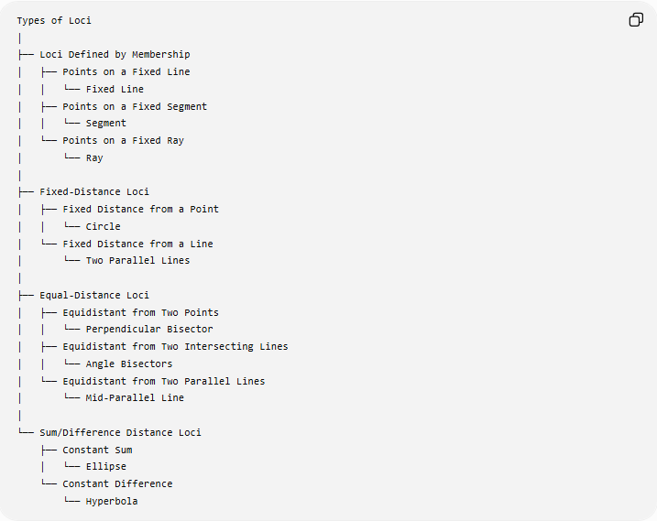
Types of Loci
│
├── Loci Defined by Membership
│ ├── Points on a Fixed Line
│ │ └── Fixed Line
│ ├── Points on a Fixed Segment
│ │ └── Segment
│ └── Points on a Fixed Ray
│ └── Ray
│
├── Fixed-Distance Loci
│ ├── Fixed Distance from a Point
│ │ └── Circle
│ └── Fixed Distance from a Line
│ └── Two Parallel Lines
│
├── Equal-Distance Loci
│ ├── Equidistant from Two Points
│ │ └── Perpendicular Bisector
│ ├── Equidistant from Two Intersecting Lines
│ │ └── Angle Bisectors
│ └── Equidistant from Two Parallel Lines
│ └── Mid-Parallel Line
│
└── Sum/Difference Distance Loci
├── Constant Sum
│ └── Ellipse
└── Constant Difference
└── Hyperbola

Key Points
# Source: AI Source: Provided by: [Data Path: Persons Table -> ID Column: 1, Name_En Column: Motasem Essam] -> From: [ChatGPT] on [7/25/2026]
- A locus is the set of all points satisfying a specified condition.
- If the condition is simply:
$$P∈l,$$
the locus is the entire fixed line.
- A line extends infinitely in both directions.
- A segment and a ray are restricted versions of a line.
- A fixed line can also act as a reference object for other loci.
- Adding another condition can reduce the locus from an entire line to a finite number of points or another geometric set.
- In coordinate geometry, a fixed-line locus is represented by a linear equation.

Conclusion
# Source: AI Source: Provided by: [Data Path: Persons Table -> ID Column: 1, Name_En Column: Motasem Essam] -> From: [ChatGPT] on [7/25/2026]
The locus of points on a fixed line is simply the entire fixed line. It is one of the most basic forms of a locus: the condition is direct membership,
$$\boxed{P∈l}$$
and every point satisfying that condition belongs to the locus. This concept also provides a foundation for more complex loci involving distances, intersections, and additional geometric constraints.

